**Bug Report – Freshii**

|  |  |  |
| --- | --- | --- |
| **Bug#** | **Description** | **Severity** |
| FRS_BG_01 | Menu does not default to the Rosedale (Freshii-760) location for Canadian users | Minor |
| FRS_BG_02 | User is able to register an account by providing an invalid email id | Minor |
| FRS_BG_03 | User is not able to sign up with valid password format with cap letter. | Minor |
| FRS_BG_04 | User is not able to sign in-sign up via menu after deleting account | Minor |
| FRS_BG_05 | The user's Signup information is not stored properly after registering an account 'using Google'. | Minor |
| FRS_BG_06 | “Use current location” functionality does not work for adding Postal code. Info. verified under My Account. | Minor |
| FRS_BG_07 | 'Password reset link' email not received to the registered email address after clicking Forgot password. | Major |
| FRS_BG_08 | Upon sign in, User is not directed to a particular store (menu) according to the Postal code entered during Sign up on iPhone and Web | Minor |
| FRS_BG_09 | All menu categories are not displayed. | Major |
| FRS_BG_10 | No scroll bar appearing even after resizing screen. | Major |
| FRS_BG_11 | Menu item Image is moving across screen. | Minor |
| FRS_BG_12 | Menu item description is not displayed. | Minor |
| FRS_BG_13 | Menu item calorie doesn't match calorie displayed under Nutrition value | Minor |
| FRS_BG_14 | User is not able to replace an ingredient more than once | Minor |
| FRS_BG_15 | User is not getting logged out in one browser, when logged out in another browser | Minor |
| FRS_BG_16 | Email address is not getting carry forwarded from the 'Login' page to 'Forgot Your Password' page | Minor |
|  | Click < Your bugs go here > |  |
| FRS_BG_17 | User is unable to successfully add Credit Card under Payment method functionality | Critical |
|  |  |  |
|  |  |  |
|  |  |  |
|  |  |  |
|  |  |  |
|  |  |  |  |  |
|  |  |  |  |  |
|  |  |  |  |  |
|  |  |  |  |  |
|  |  |  |  |  |  |
|  |  |  |  |  |  |
|  |  |  |  |  |  |

|  |  |
| --- | --- |
| Bug Id | FRS_BG_01 |

|  |  |
| --- | --- |
| Brief Summary | Menu does not default to the Rosedale (Freshii-760) location for Canadian users |

|  |  |
| --- | --- |
| Severity | Minor |

|  |
| --- |
| Steps to Reproduce |

1. Open the Application URL : <https://web-uat.freshii.com/en>

2. Enter valid Canadian postal code when prompted.

3. Click ‘Find Store’ button.

**Expected Result:**

Menu should be defaulted to the Rosedale (Freshii-760) location for Canadian users.

**Actual Result:**

Guest is prompted to enter a location and Menu shown is not from the Rosedale (Freshii-760) location.

|  |
| --- |
| Screenshot |

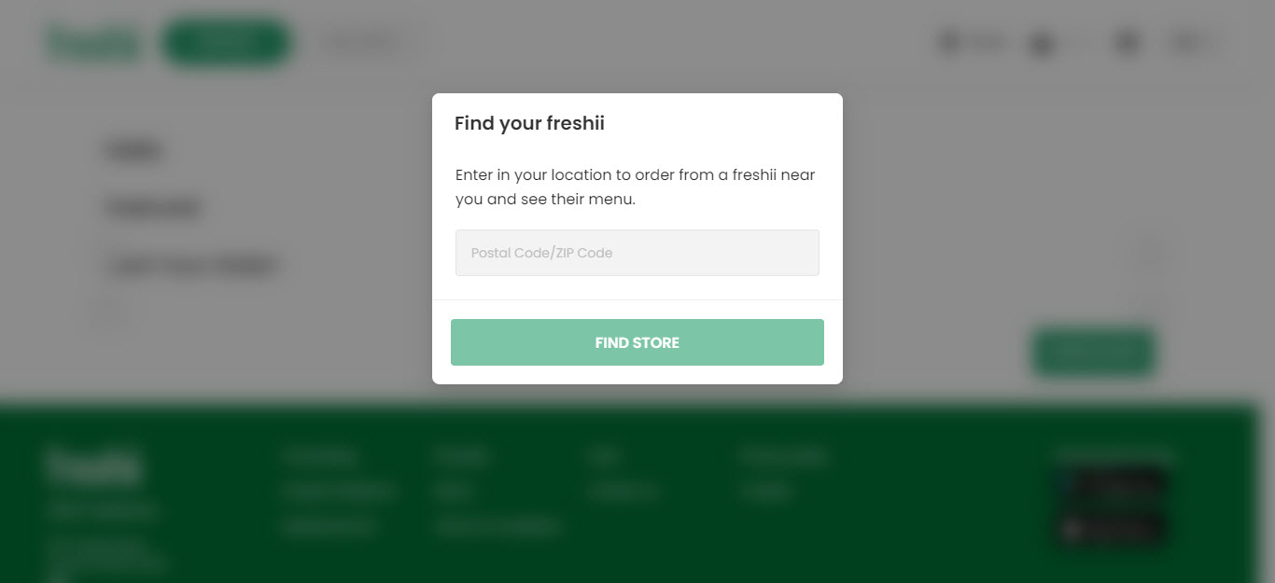

Top

|  |  |
| --- | --- |
| Bug Id | FRS_BG_02 |

|  |  |
| --- | --- |
| Brief Summary | User is able to register an account by providing an invalid email id |

|  |  |
| --- | --- |
| Severity | Minor |

|  |
| --- |
| Steps to Reproduce |

1. Open the Application URL

2. Enter valid Canadian postal code when prompted.

3. Click the circle user icon located on the top left on the main menu.

4. Click ‘Sign In/Sign Up.

5. Click ‘Sign Up’ on the bottom of the Sign in page.

4. Enter valid details into fields on the 'Sign up for a Freshii Account' page

5. Enter invalid email id e.g. “abcd@gmail.co”into the 'Email' field

8. Enter valid password.

6. Click on 'Next' button

10. Enter valid postal code.

11. Click ‘Create Account’

**Expected Result:**

Warning message informing the User to enter a valid email id should be displayed.

**Actual Result:**

Email field is accepting the invalid email id and no field level warning message is displayed for this field, instead User account is getting created with invalid email id.

|  |
| --- |
| Screenshot |

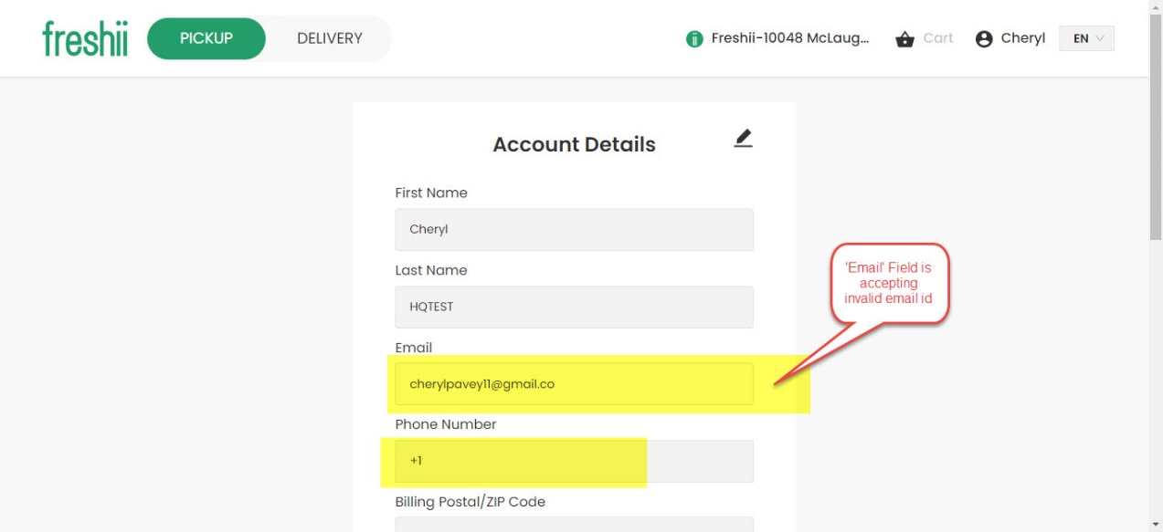 Top

|  |  |
| --- | --- |
| Bug Id | FRS_BG_03 |

|  |  |
| --- | --- |
| Brief Summary | User is not able to register an account by providing a valid password format with cap letter. |

|  |  |
| --- | --- |
| Severity | Minor |

|  |
| --- |
| Steps to Reproduce |

1. Open the Application URL

2. Enter valid Canadian postal code when prompted.

3. Click the circle user icon located on the top left on the main menu.

4. Click ‘Sign In/Sign Up.

5. Click ‘Sign Up’ on the bottom of the Sign in page.

4. Enter valid details into the fields displayed on the 'Sign up for a Freshii Account' page

8. Enter password with a capital letter, numbers and special characters e.g. A12345 (at least 8 characters).

**Expected Result:**

Password should be accepted as requirement is ‘Password must be at least 8 characters, and contain letters, numbers, and special characters’

**Actual Result:**

Password is not accepted.

|  |
| --- |
| Screenshot |

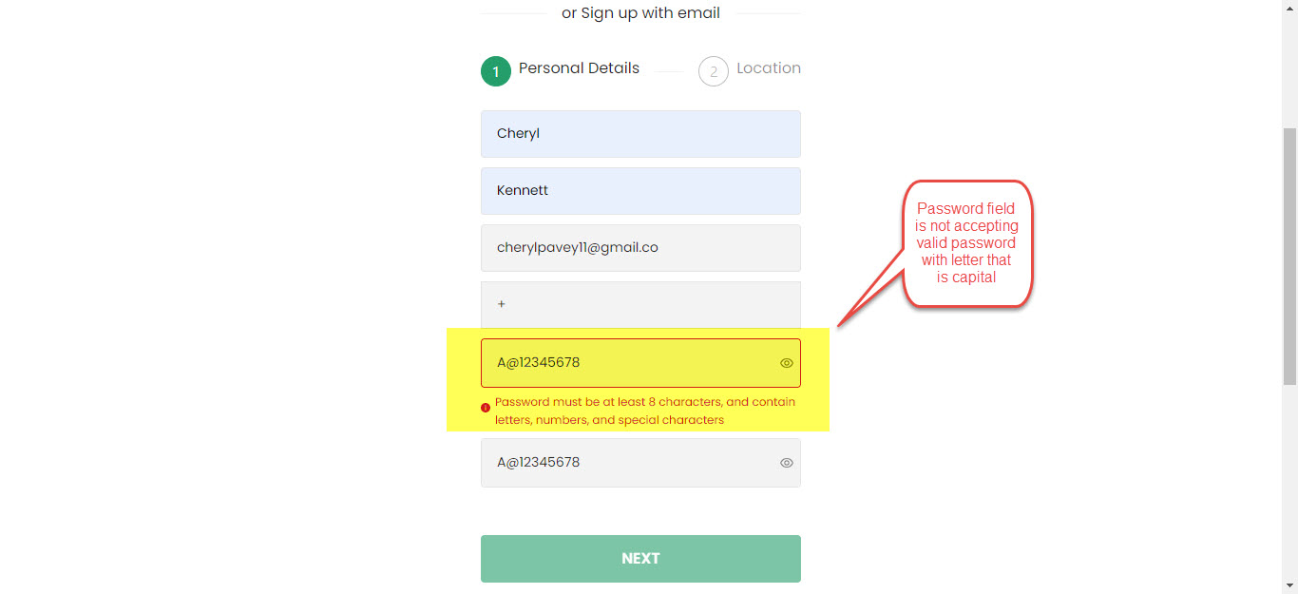

Top

|  |  |
| --- | --- |
| Bug Id | FRS_BG_04 |

|  |  |
| --- | --- |
| Brief Summary | User is not able to sign in-sign up via menu after deleting account |

|  |  |
| --- | --- |
| Severity | Minor |

|  |
| --- |
| Steps to Reproduce |

1. Open the Application URL
2. Enter valid Canadian postal code when prompted.
3. Click the circle user icon located on the top left on the main menu.
4. Click ‘Sign In/Sign Up.
5. Enter valid email-id and password.
6. Click Sign in.
7. Click the circle user icon located on the top left on the main menu.
8. Click account details.
9. Scroll down and click Delete my account.
10. Enter DELETE
11. Click DELETE MY ACCOUNT
12. Click the circle user icon located on the top left on the main menu.
13. Click ‘Sign In/Sign Up.

**Expected Result:**

User should be directed to sign in page.

**Actual Result:**

Clicking ‘Sign In/Sign’ Up has no response.

|  |
| --- |
| Screenshot |

Top

|  |  |
| --- | --- |
| Bug Id | FRS_BG_05 |

|  |  |
| --- | --- |
| Brief Summary | The user's Signup information is not stored properly after registering an account 'using Google'. |

|  |  |
| --- | --- |
| Severity | Minor |

|  |
| --- |
| Steps to Reproduce |

1. Open the Application URL
2. Enter valid Canadian postal code when prompted.
3. Click the circle user icon located on the top left on the main menu.
4. Click ‘Sign In/Sign Up.
5. Enter valid email-id and password.
6. Click Sign in.
7. Click the circle user icon located on the top left on the main menu.
8. Click account details.

**Expected Result:**

First name field should display First Name and last name field should display last name.

**Actual Result:**

First and Last Name are displayed in First Name field and Last Name field is blank.

|  |
| --- |
| Screenshot |

Top

|  |  |
| --- | --- |
| Bug Id | FRS_BG_06 |

|  |  |
| --- | --- |
| Brief Summary | “Use current location” functionality does not work for adding Postal code. Info. verified under My Account. |

|  |  |
| --- | --- |
| Severity | Minor |

|  |
| --- |
| Steps to Reproduce |

1. Open the Application URL

2. Enter valid Canadian postal code when prompted.

3. Click the circle user icon located on the top left on the main menu.

4. Click ‘Sign In/Sign Up.

5. Click ‘Sign Up’ on the bottom of the Sign in page.

6. Enter valid details into fields on the 'Sign up for a Freshii Account' page.

7. Click on 'Next' button

**Expected Result:**

User should be prompted to use current location.

**Actual Result:**

There is no option to use current location and only postal Code field is displayed.

|  |
| --- |
| Screenshot |

Top

|  |  |
| --- | --- |
| Bug Id | FRS_BG_07 |

|  |  |
| --- | --- |
| Brief Summary | 'Password reset link' email not received to the registered email address after clicking Forgot password. |

|  |  |
| --- | --- |
| Severity | Major |

|  |
| --- |
| Steps to Reproduce |

1. Open the Application URL
2. Enter valid Canadian postal code when prompted.
3. Click the circle user icon located on the top left on the main menu.
4. Click ‘Sign In/Sign Up.
5. Click Forgot Password on signin page.
6. Enter registered email-id.
7. Click Send Reset Link.
8. Confirm if reset link email is received.

**Expected Result**

Password reset email should be received.

**Actual Result**

No password reset link email received.

|  |
| --- |
| Screenshot |

Not Applicable

Top

|  |  |
| --- | --- |
| Bug Id | FRS_BG_08 |

|  |  |
| --- | --- |
| Brief Summary | Upon sign in, User is not directed to a particular store (menu) according to the Postal code entered during Sign up on iPhone and Web. |

|  |  |
| --- | --- |
| Severity | Minor |

|  |
| --- |
| Steps to Reproduce |

1. Open the Application URL
2. Enter valid Canadian postal code when prompted.
3. Click the circle user icon located on the top left on the main menu.
4. Click ‘Sign In/Sign Up.
5. Enter valid email-id and password.
6. Click Sign in.

**Expected Result**

User should be directed to a particular store (menu) according to the Postal code entered during Sign up on iPhone and Web.

**Actual Result**

Store (menu) is not updated according to the Postal code entered during Sign up.

|  |
| --- |
| Screenshot |

Not Applicable

Top

|  |  |
| --- | --- |
| Bug Id | FRS_BG_09 |

|  |  |
| --- | --- |
| Brief Summary | All menu categories are not displayed. |

|  |  |
| --- | --- |
| Severity | Major |

|  |
| --- |
| Steps to Reproduce |

1. Open the Application URL
2. Enter valid Canadian postal code when prompted.
3. Click the circle user icon located on the top left on the main menu.
4. Click ‘Sign In/Sign Up.
5. Enter valid email-id and password.
6. Click Sign in.
7. Click Order Now

**Expected Result:**

All Menu categories should be visible and able to be selected.

**Actual Result:**

User is not able to view all menu categories.

|  |
| --- |
| Screenshot |

|  |  |
| --- | --- |
| Bug Id | FRS_BG_10 |

|  |  |
| --- | --- |
| Brief Summary | No scroll bar appearing even after resizing screen. |

|  |  |
| --- | --- |
| Severity | Major |

|  |
| --- |
| Steps to Reproduce |

1. Open the Application URL
2. Enter valid Canadian postal code when prompted.
3. Click the circle user icon located on the top left on the main menu.
4. Click ‘Sign In/Sign Up.
5. Enter valid email-id and password.
6. Click Sign in.
7. Click Order Now

**Expected Result:**

Scroll bar should appear to navigate the screen and view all categories.

**Actual Result:**

No scroll bar appears even after resizing the screen.

|  |
| --- |
| Screenshot |

|  |  |
| --- | --- |
| Bug Id | FRS_BG_11 |

|  |  |
| --- | --- |
| Brief Summary | Menu item Image is moving across screen. |

|  |  |
| --- | --- |
| Severity | Minor |

|  |
| --- |
| Steps to Reproduce |

1. Open the Application URL
2. Enter valid Canadian postal code when prompted.
3. Click the circle user icon located on the top left on the main menu.
4. Click ‘Sign In/Sign Up.
5. Enter valid email-id and password.
6. Click Sign in.
7. Click Order Now.
8. Click on a menu item.
9. Scroll to the bottom of the page of the item.

**Expected Result:**

Menu item image should not move across the screen and block clickable content.

**Actual Result:**

Menu item Image is moving across screen and blocking text and other pages.

|  |
| --- |
| Screenshot |

|  |  |
| --- | --- |
| Bug Id | FRS_BG_12 |

|  |  |
| --- | --- |
| Brief Summary | Menu item description is not displayed. |

|  |  |
| --- | --- |
| Severity | Minor |

|  |
| --- |
| Steps to Reproduce |

1. Open the Application URL
2. Enter valid Canadian postal code when prompted.
3. Click the circle user icon located on the top left on the main menu.
4. Click ‘Sign In/Sign Up.
5. Enter valid email-id and password.
6. Click Sign in.
7. Click Order Now.
8. Click on a menu item from the smoothie’s category.

**Expected Result:**

User should be shown item description.

**Actual Result:**

Menu item description is not displayed.

|  |
| --- |
| Screenshot |

|  |  |
| --- | --- |
| Bug Id | FRS_BG_13 |

|  |  |
| --- | --- |
| Brief Summary | Menu item calorie doesn't match calorie displayed under Nutrition value. |

|  |  |
| --- | --- |
| Severity | Minor |

|  |
| --- |
| Steps to Reproduce |

1. Open the Application URL
2. Enter valid Canadian postal code when prompted.
3. Click the circle user icon located on the top left on the main menu.
4. Click ‘Sign In/Sign Up.
5. Enter valid email-id and password.
6. Click Sign in.
7. Click Order Now.
8. Click on a menu item.
9. Click on nutrition on the right of the item page.
10. Calories in the nutrition info differs from the item title description calorie info.

**Expected Result:**

Calories in the nutrition info should match the item title description calorie info.

**Actual Result:**

Menu item calorie doesn't match calorie displayed under Nutrition value.

|  |
| --- |
| Screenshot |

|  |  |
| --- | --- |
| Bug Id | FRS_BG_14 |

|  |  |
| --- | --- |
| Brief Summary | User is not able to replace an ingredient more than once |

|  |  |
| --- | --- |
| Severity | Minor |

|  |
| --- |
| Steps to Reproduce |

1. Open the Application URL
2. Enter valid Canadian postal code when prompted.
3. Click the circle user icon located on the top left on the main menu.
4. Click ‘Sign In/Sign Up.
5. Enter valid email-id and password.
6. Click Sign in.
7. Click Order Now.
8. Click on a menu item with replaceable ingredients ie. Buddha's Satay Bowl
9. Click the ‘Replace’ button next to an ingredient
10. Click ‘Full’ next to an ingredient in the popup list.
11. Click replace.

**Expected Result:**

Upon replacing an ingredient, user should be able to replace again and the replace button should remain.

**Actual Result:**

User is not able to replace an ingredient more than once as

the option goes away.

|  |
| --- |
| Screenshot |

|  |  |
| --- | --- |
| Bug Id | FRS_BG_15 |

|  |  |
| --- | --- |
| Brief Summary | User is not getting logged out in one browser, when logged out in another browser |

|  |  |
| --- | --- |
| Severity | Minor |

|  |
| --- |
| Steps to Reproduce |

1. Simultaneously perform the below steps in two browsers.
2. Open the Application URL
3. Enter valid Canadian postal code when prompted.
4. Click the circle user icon located on the top left on the main menu.
5. Click ‘Sign In/Sign Up.
6. Enter valid email-id and password.
7. Click Sign in.
8. Click the circle user icon located on the top left on the main menu.
9. Scroll down to select logout in one browser.
10. Note that user is not logged out in the other browser.

**Expected Result:**

User should be logged out in both browsers after logging out in one.

**Actual Result:**

User is not getting logged out in one browser, when logged out in another browser

|  |
| --- |
| Screenshot |

|  |  |
| --- | --- |
| Bug Id | FRS_BG_16 |

|  |  |
| --- | --- |
| Brief Summary | Email address is not getting carry forwarded from the 'Login' page to 'Forgot Your Password' page |

|  |  |
| --- | --- |
| Severity | Minor |

|  |
| --- |
| Steps to Reproduce |

1. Open the Application URL
2. Enter valid Canadian postal code when prompted.
3. Click the circle user icon located on the top left on the main menu.
4. Click ‘Sign In/Sign Up.
5. Enter Registered Email Id and invalid password.
6. Click Forgot Password on sign in page.

**Expected Result:**

Email address given in Login page should get carry forwarded to 'Forgot Your Password' page

**Actual Result:**

Email address is not getting carry forwarded from the 'Login' page to 'Forgot Your Password' page

|  |
| --- |
| Screenshot |

* *Please copy and paste the following on pages below and fill in the details of your bugs.*

|  |  |
| --- | --- |
| Bug Id |  |

|  |  |
| --- | --- |
| Brief Summary |  |

|  |  |
| --- | --- |
| Severity |  |

|  |
| --- |
| Steps to Reproduce |

**Expected Result:**

**Actual Result:**

|  |
| --- |
| Screenshot |

|  |  |
| --- | --- |
| Bug Id | FRS_BG_17 |

|  |  |
| --- | --- |
| Brief Summary | User is unable to successfully add Credit Card under Payment method functionality. |

|  |  |
| --- | --- |
| Severity | Critical |

|  |
| --- |
| Steps to Reproduce |

1. Open the Application URL
2. Enter valid Canadian postal code when prompted.
3. Click the circle user icon located on the top left on the main menu.
4. Click ‘Sign In/Sign Up.
5. Enter valid email-id and password.
6. Click Sign in.
7. Click Order Now.
8. Click on a menu item.
9. Click Add to Cart.
10. Click No Thanks on the Pop-up
11. Click Add to Cart
12. Click Checkout
13. Click No Thanks.
14. Click Select Payment Method on the checkout screen.
15. Click Add Debit/Credit card
16. Enter valid details into fields
17. Click Save Card.

**Expected Result:**

Payment method should be successfully saved and user should be able to perform other selections.

**Actual Result:**

User is unable to successfully add Credit Card under Payment method functionality and a service not allowed error is displayed.

|  |
| --- |
| Screenshot |